20CYS403 – WEB APPLICATION SECURITY
SECURE WEB APPLICATION DEVELOPMENT
Ponvedica M S
CB.SC.U4CYS23034
First, we are creating the database and the table name users and products
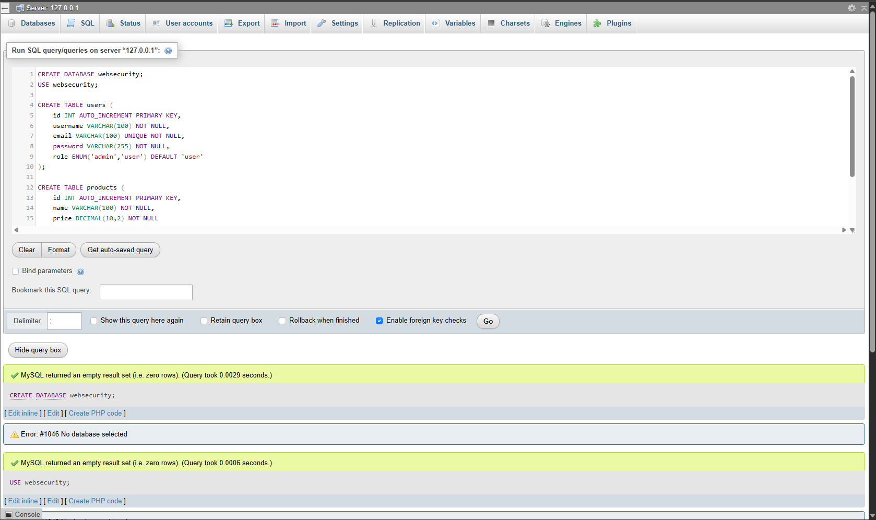1. Create a registration page [username, email, password]. Hash the password using bcrypt before storing it in the database.
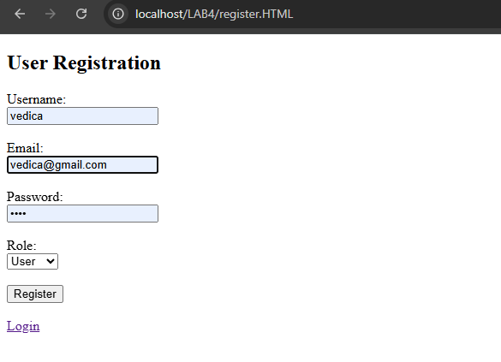
First, we are registering as user. And then we are storing the password in hash using bcrypt in the database.
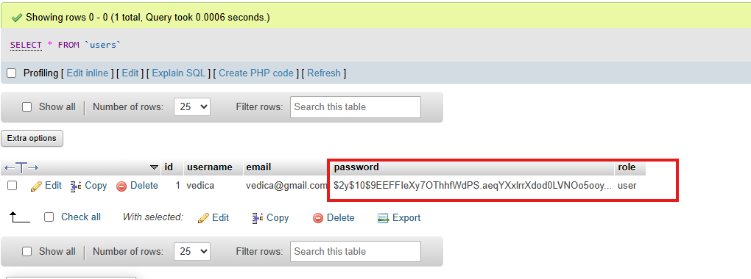
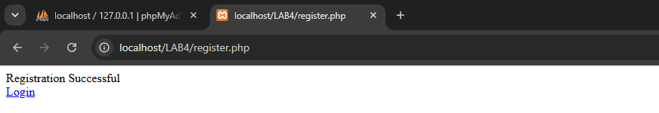
2. Create a login page and try to login with the registered user. Verify the entered password against the stored hash and create a session on success.
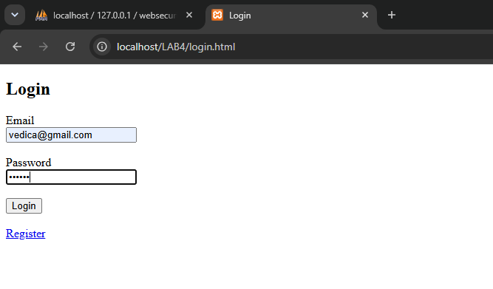
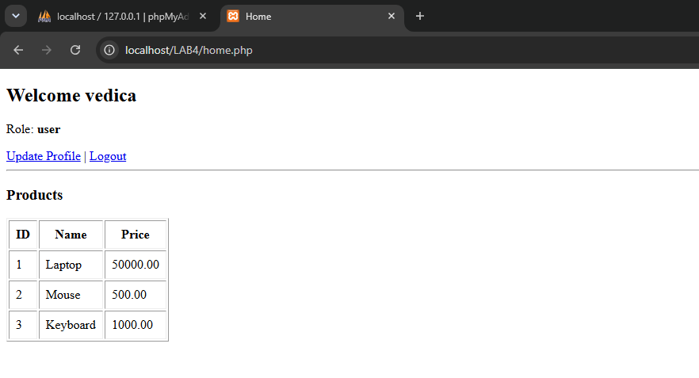
3. Add client-side validation for login and registration. Check required fields, email format, and password length using HTML5/JavaScript.
- below are the client side validation for registration and login page
- if we leave the spaces empty, it asks to fill it out
- if the email isn’t in correct form
- if password length is short or incorrect.
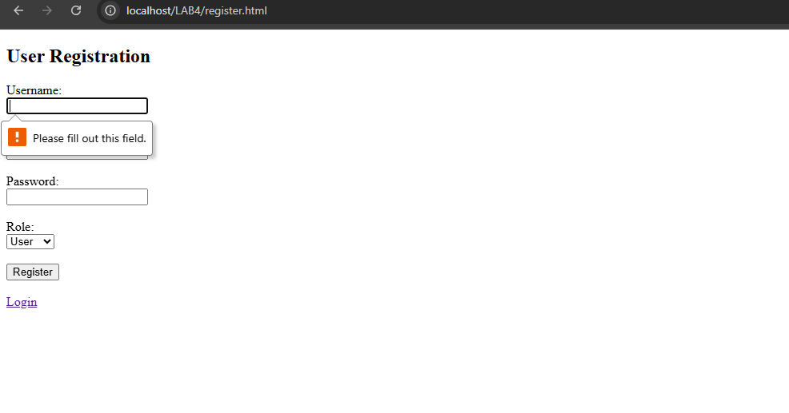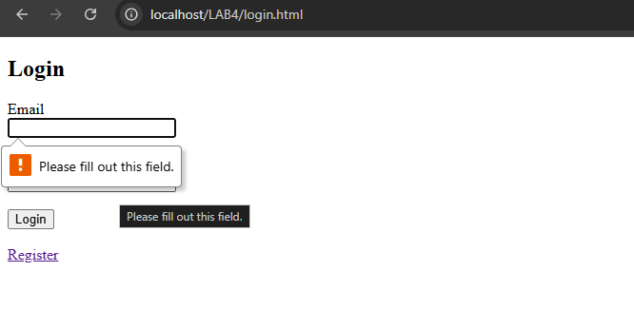
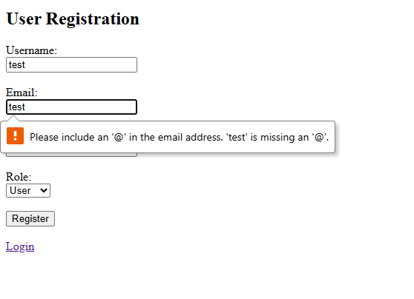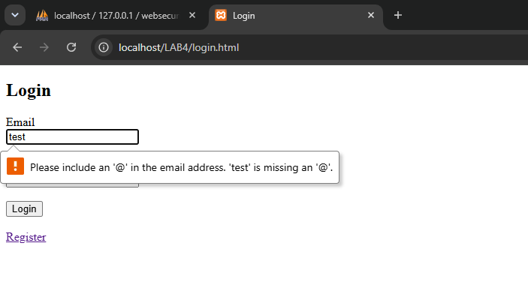
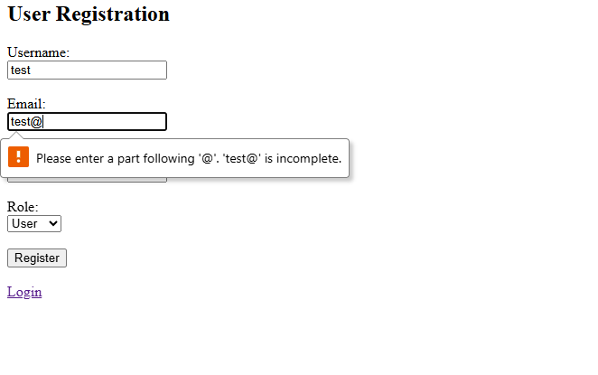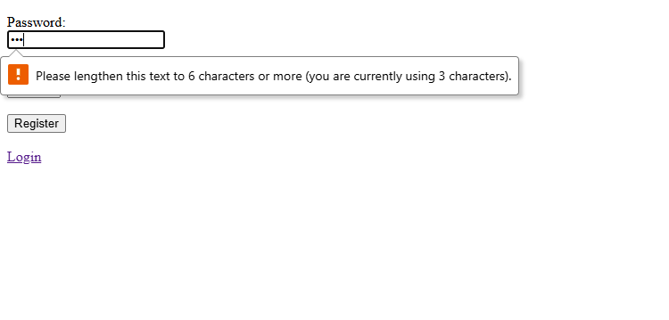
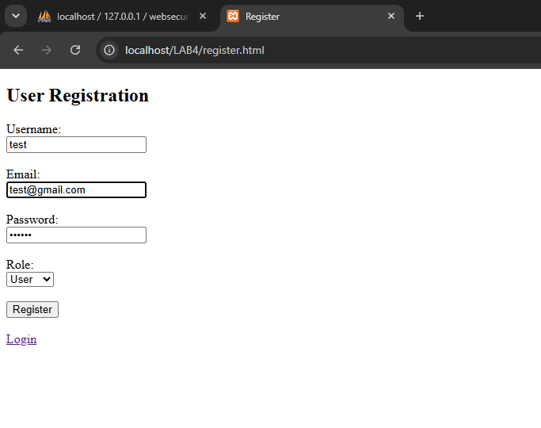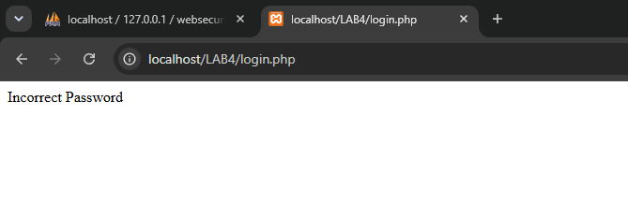
4. Create and manage session cookies and clear cookies or sessions on logout.
Logging to the user(test) and it re directs to the home page
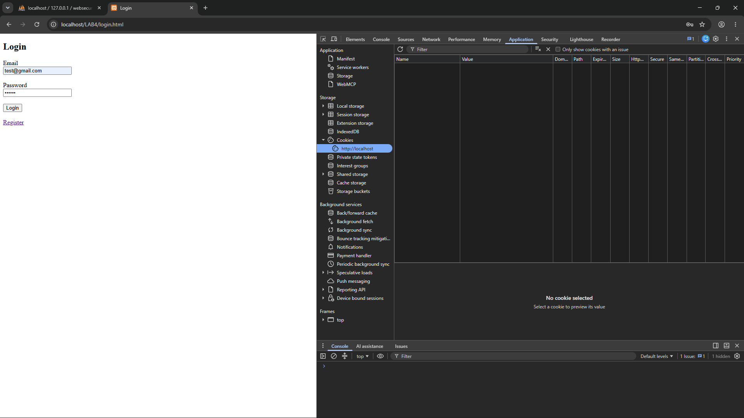

Now, the cookies are stored
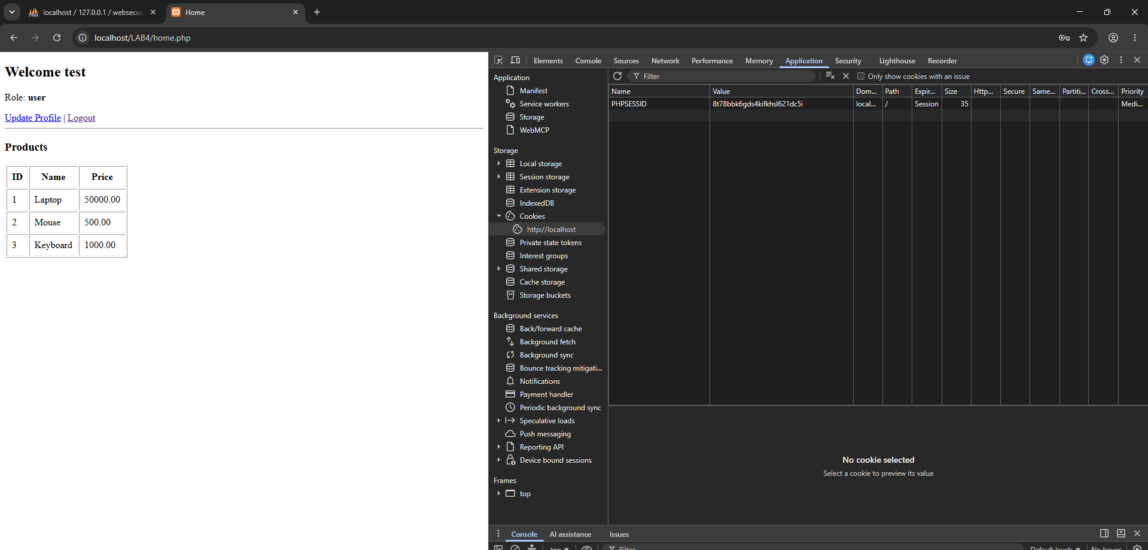
When we try to logout, the cookies are cleared.
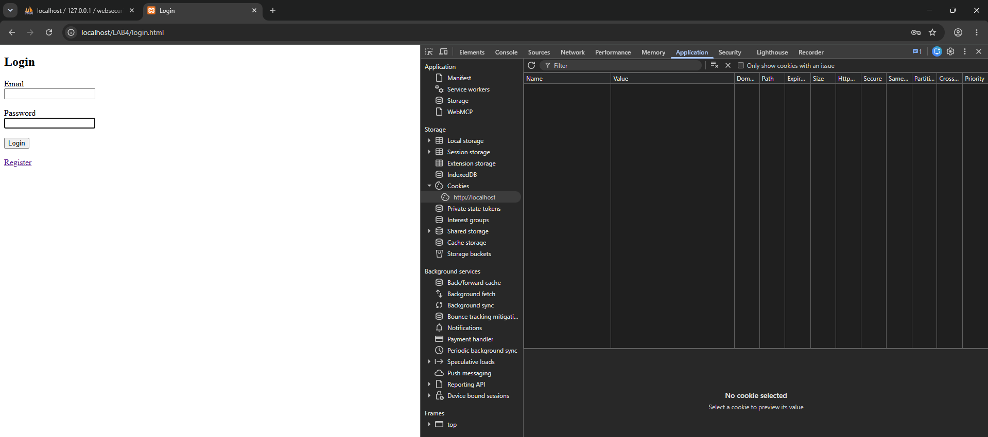
When I try to redirect to the home page, it redirects to the login page stating that the cookies are cleared successfully.
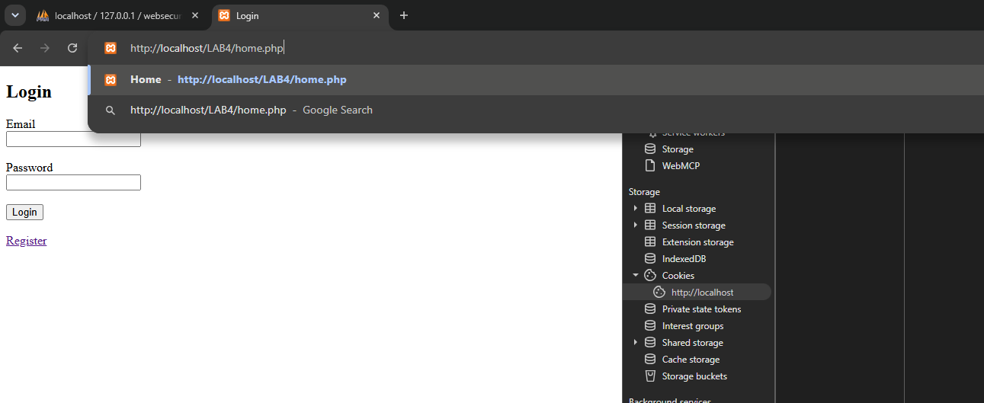

- It redirects back to the login page.
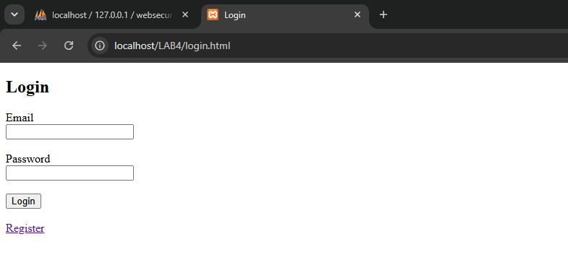
5. Add a homepage (product page) having some sample data to be retrieved and displayed on successful login. Protect this route so it is accessible only with a valid session.
After logging in, the product page is successfully visited here.
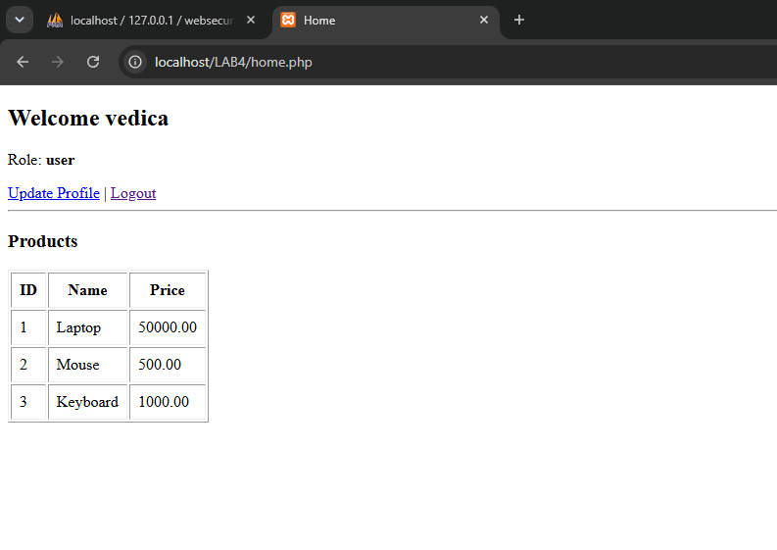

Once I log out and then try to access the home page directly in url – it’ll redirect to the login page indicating tht the route is protected and can be accessed only
When I access this directly, its redirecting to the login page

6. Update username [update profile]. Allow the logged-in user to edit their username, identifying the user from the session rather than form data.
I’m logging in as test@gmail.com with the existing user name as test
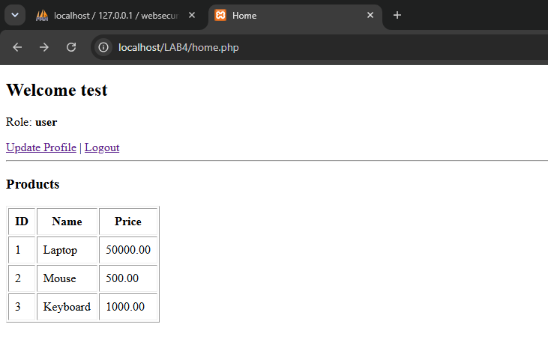
Now the new username is testtt
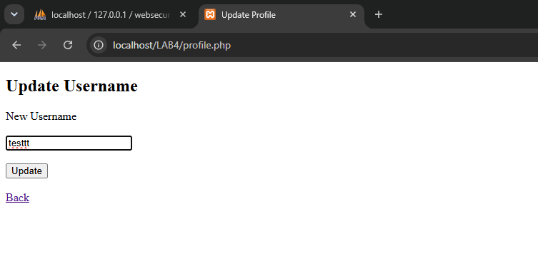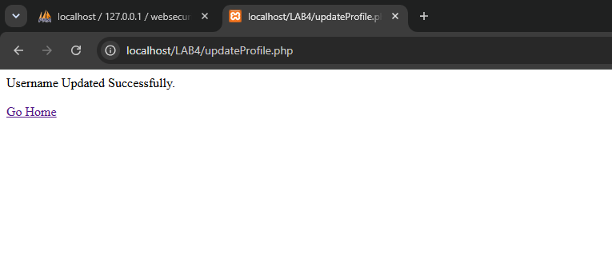
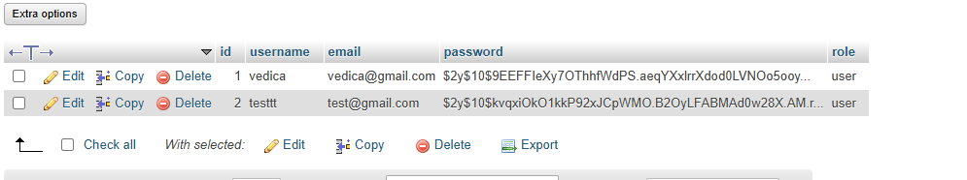

7. On registration, add a role option (admin, user) , or add, update remove product list access to only admin (RBAC). Show the entire database details after add/update/remove using Fetch API. Restrict at least one route to admin users only; other roles should receive a 403.

Registration as an admin
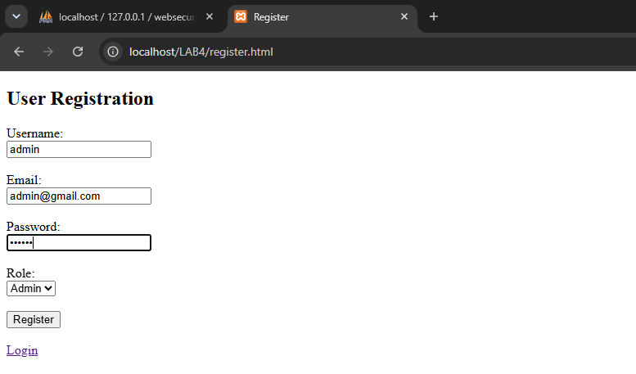
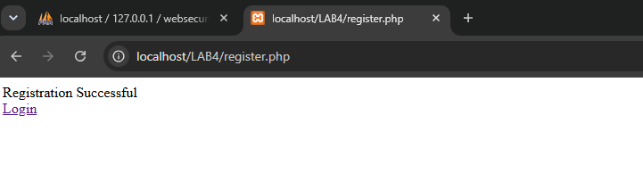
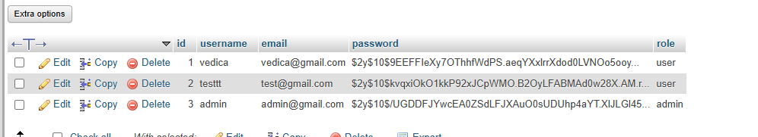
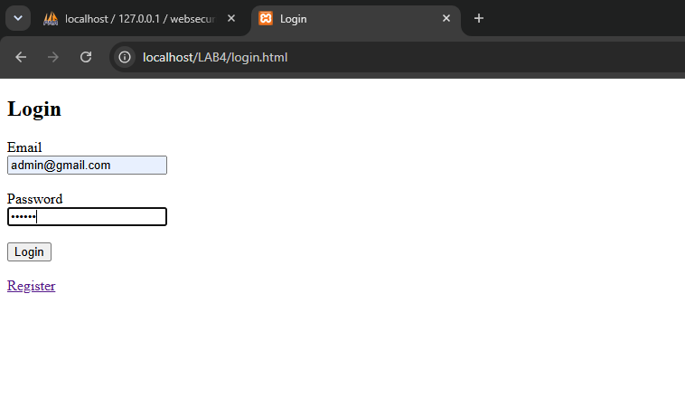
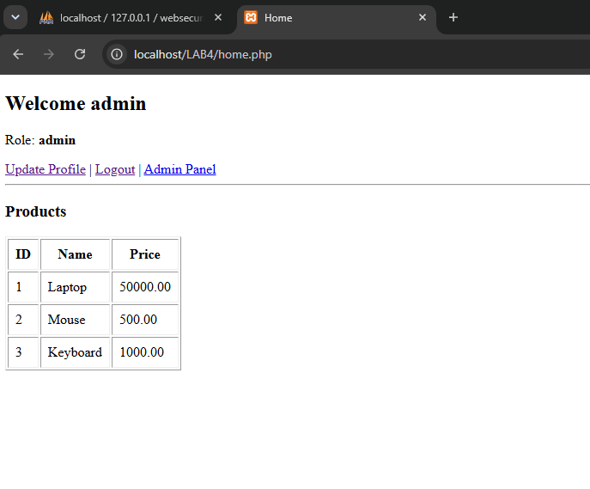
Admin can ADD
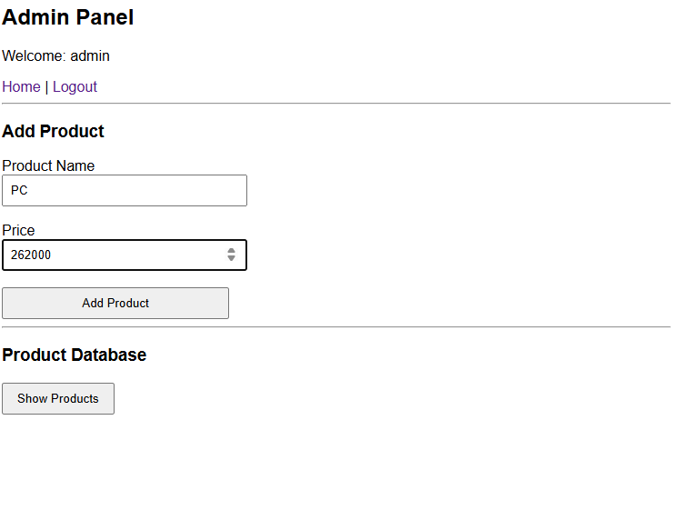
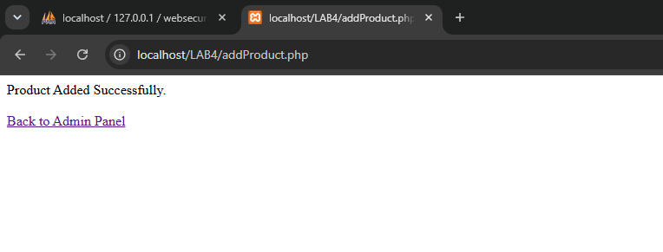
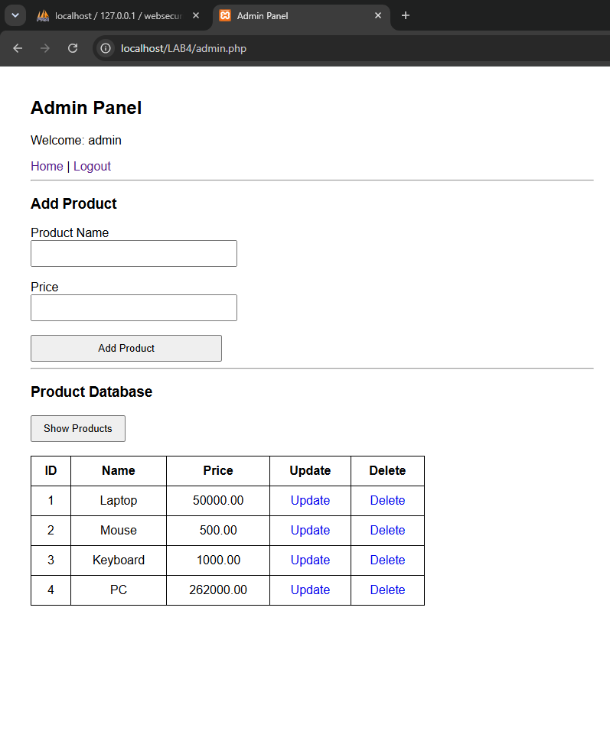
Admin can UPDATE
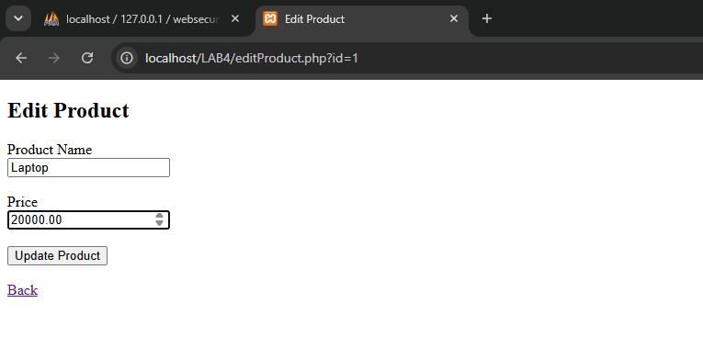
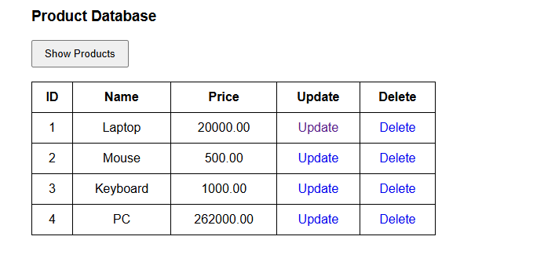
Admin can DELETE
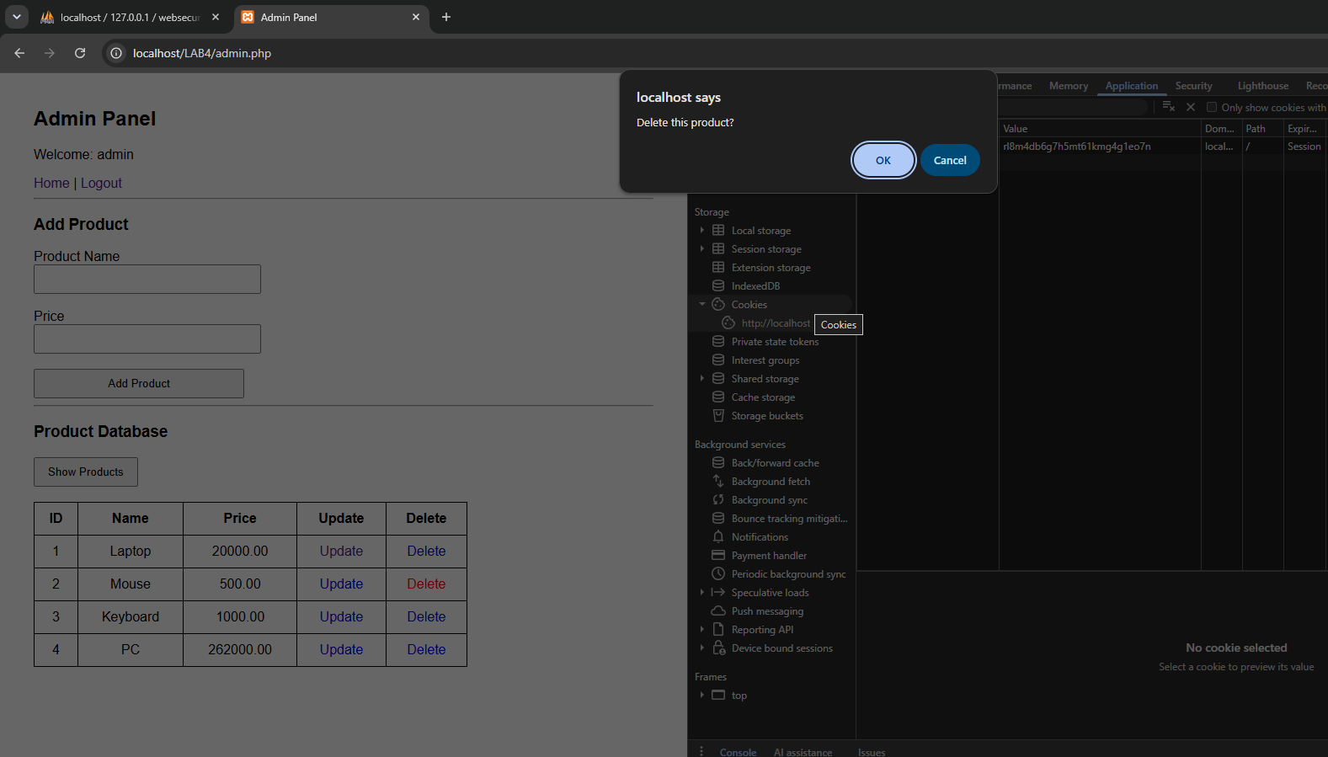
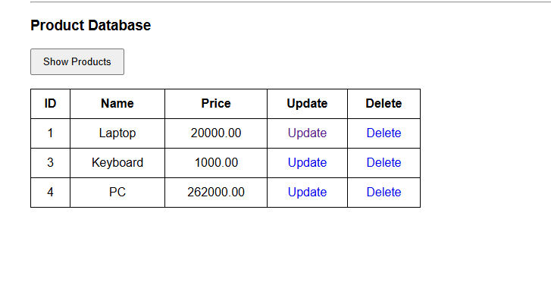

Logged in as testtt user
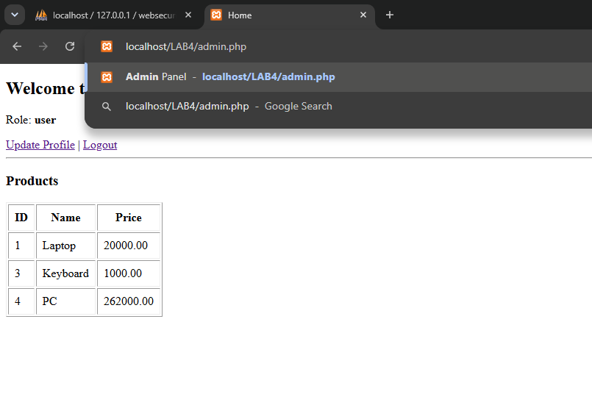
We can’t access to the admin page as a user
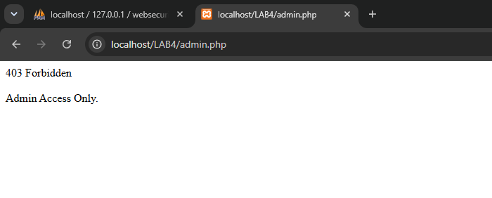
8. Add server-side validation for login and registration. Re-validate the same rules on the server and sanitize inputs.
Cmd line server side validations
